FOP PRACTICAL 5

AMBER SHUKLA

A8_B3_42

1. Write a C program to implement Linear Search and Binary Search.

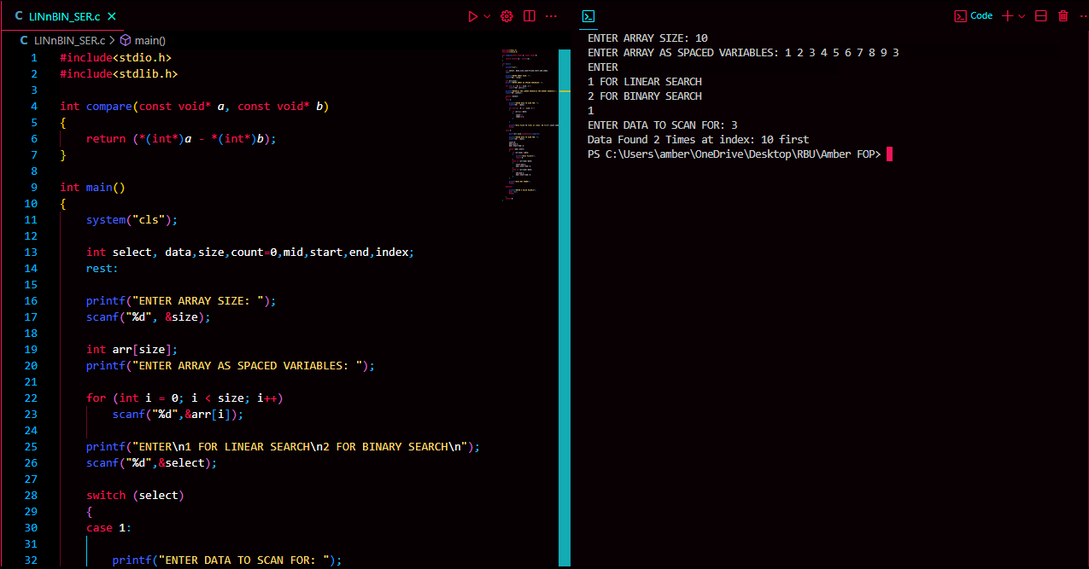

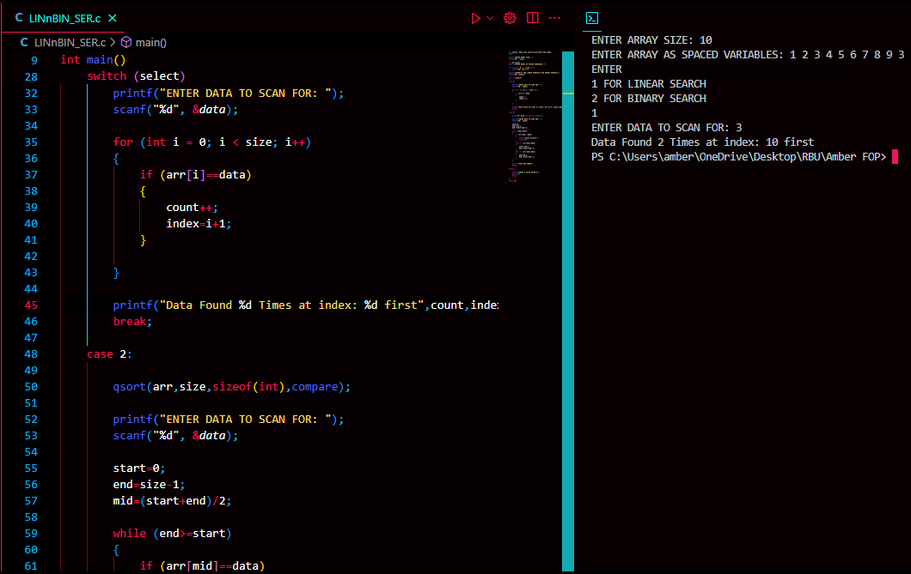

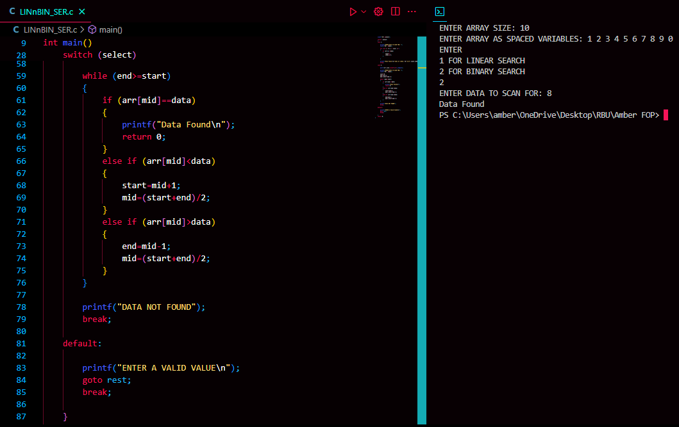

1. Write a C program to implement Bubble Sort and Insertion Sort.

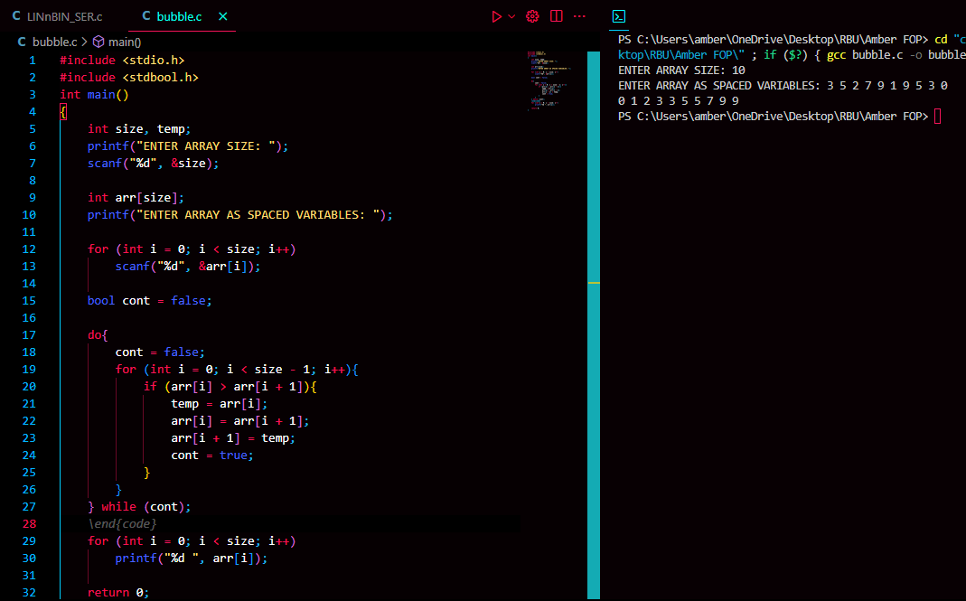

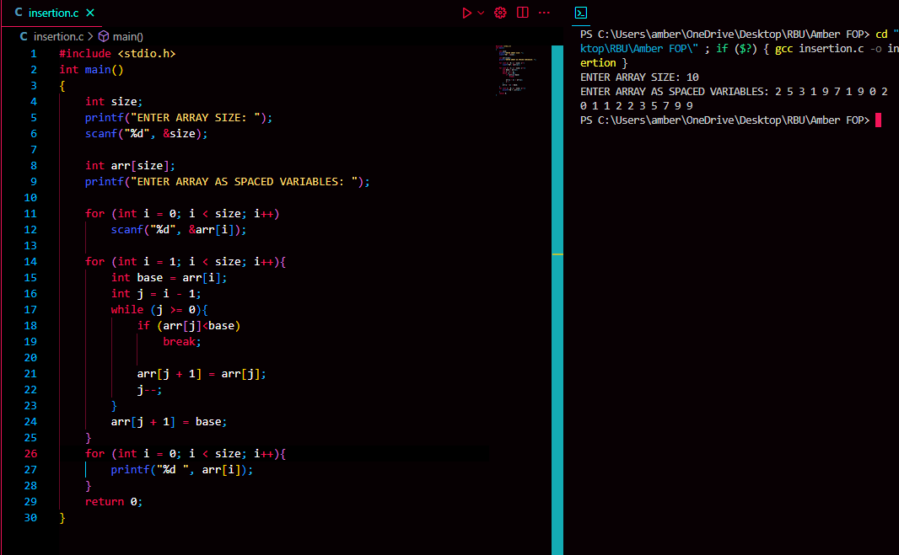

1. Write a C program to implement Multiplication of two Matrices.



